**2013 Yearly Report from Brother Fausto Piña Dominican Republic**

Brothers and sisters at Western Hills Church of Christ, God bless you all!

I pray that my God blesses all of you brothers and sisters. This New Year is very important because we are nearer the Second coming of Jesus.

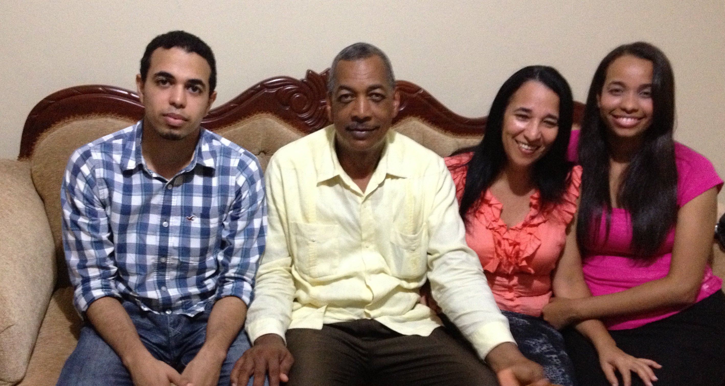During this last year, we had some baptisms in the churches, and all members persevered in the churches, and this was very important for me. I will tell about the churches are:  The church at ***Mata de Platano***, near the mountains, began their meetings in a church building that is in construction. It is a small congregation. I visited them one Thursday and two Sundays every month. There is some local leadership, but they are my responsibility until they have elders. I teach lessons over the radio and they listen to the program.

The ***church in Jarabacoa***: Jarabacoa is a small and beautiful town, and there are very special people in Christ who have a great love for every one. This church has more members than Mata de Platano. I visit them every week on Sunday afternoon, and on Thursday evenings.

***Sabaneta, Santiago***, is the second more important city in the Dominican Republic. This is a small congregation that has not been in existence for very long, but there are other congregations of the church of Christ in this city.  I work there every Tuesday and one in Sunday of the month. The church does not have its own place for worship, but they do not have to pay rent, so it is a blessing. The owner of building is member of the church, and he said, "You can meet here as long as I am alive."

At ***La Vega***, the city where my family and I live, there are two churches, but it is as if it was one church, we do a lot of activities together. Last year was a beautiful year because we had many activities. Brother Kirpatrick, and Gabino Rico who translated into Spanish, presented a series of evangelistic messages; On another occasion, during the summer, a group from a church in Arkansas came with brother Robert Swain. He presented a series of conferences every night including children’s activities both in La Vega and Jarabacoa.

A special visitor was Armando Hernández, he visited and taught at all churches mentioned above, plus he spoke at one of my radio programs, and was on two television interviews during times that normally preach and teach the Word of God. This was a very special time for my family and me since we have known him for many years.

My work this past year was very hard. I preached the gospel by television every Saturday and Sunday, Monday, Wednesday and some other days of the week as the opportunity arises. Also I preached the gospel by radio every day from Monday to Saturday. I write two articles for digital news, every week. It was exciting to know that many people read it. Also I wrote small messages on Facebook and Twitter. In addition I preached the gospel house to house, and I visited the brothers and sisters from Monday to Saturday. This past year I attended the "Ibero-American Encounter of leaders and workers of the churches of Christ" held in Managua, Nicaragua and I was in the company of preachers from many Latin American countries.

**Plans for 2014:**

I plan to continue what I have done this past year. I hope for better results than last year. I will start a series of classes for leaders of the churches in this region of the country. I also plan to conduct evangelistic campaigns in other countries. So far I have invitations from Guatemala, and Mexico.

Thank you so much for your financial and spiritual support to help me do what I do. I appreciate everything you do for me, because it makes it easier for me to do all things that God has commanded me to do. I am a servant of God, and I am committed to do what my Lord has told me to do. Thanks because you put your hearts in God to help in his work, I hope that God will pay you for that; everyone will receive his reward from God.

In Christ,

Fausto Piña Bello